Basic Git workflow for setting up a new Project on GitHub

**PURPOSE OF DOCUMENT:**

The purpose of this document is to provide a usage overview for individuals who are new to using GitHub for version control. The document offers basic instructions for uploading documents to GitHub, which beginners can copy and follow to perform basic operations.

**AUDIENCE:**

The primary audience of the document is beginners who use GitHub on Mac computers.

**SCOPE AND OBJECTIVES:**

This process document aims to provide an overview and step-by-step guidance for beginners using GitHub on Mac computers. It covers basic instructions for starting a new project, installing Git on a local Mac computer, updating documents using Git, linking a local folder to a GitHub project, and pushing changes from a local Git repository to a GitHub project. The document targets individuals who are new to GitHub and are seeking fundamental instructions to perform basic operations.

**STEPS：**

**Step 1: Create a Local Text Document**

Create a new text document on your desktop and name it 'exercise.txt'.

**Step 2: Initialize a Git Repository:**

Open the Terminal and navigate to the directory where "exercise.txt" is located:

* Use the command: **‘cd ~/Desktop’**
* Then use the command:**‘ls’** to confirm the location.

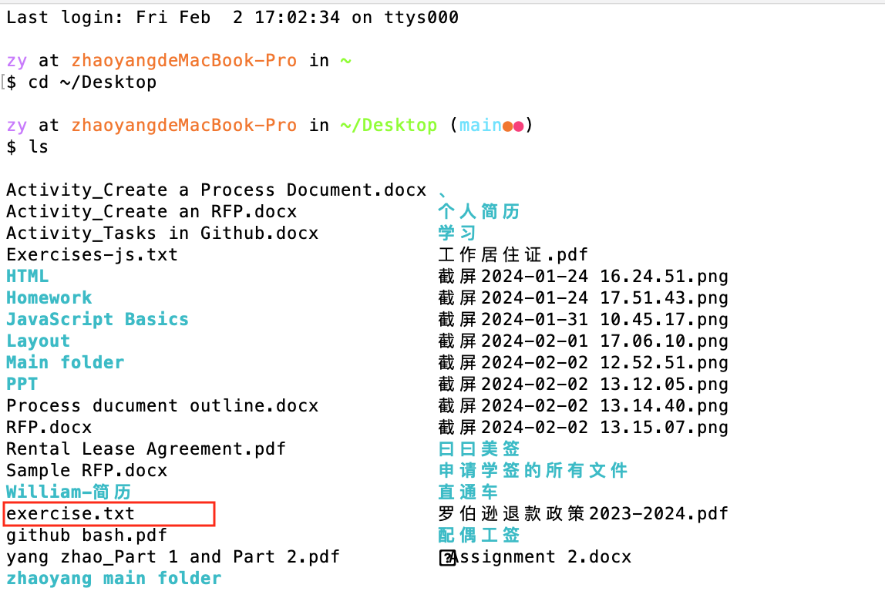

* Initialize the Git repository: Execute the command: **‘git init’**

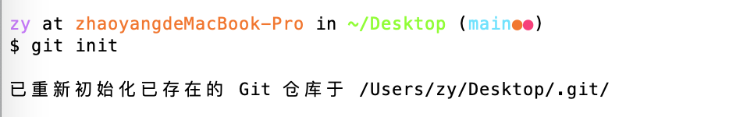

**Step 3: Add Changes to the Text Document:**

Open the 'exercise.txt' file with a text editor like VSCode.

Make some changes to the text document.

**Step 4: Stage and Commit Changes:**

**Problems encountered：**I stored exercise.txt in desktop, but the terminal showed me the wrong path, it showed the txt was in my ‘JavaScript basics folder. Then I put it in ‘yang_yang’ folder, and re-executed the command：

* Stage the changes using the following Git command:

**git add .**



* **Commit changes**

Commit the changes with a meaningful message:

**‘git commit -m** **Add exercise.txt’**

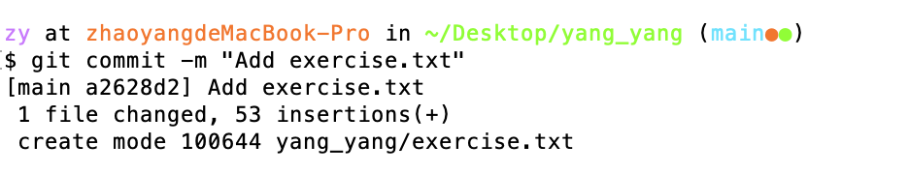

**Step 5: Rollback to Initial Snapshot**

* Execute the “git log” command to find the initial commit ID:

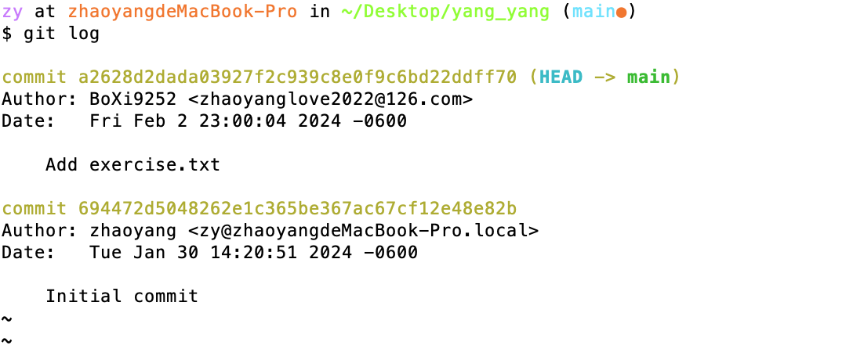

* Execute the following command to rollback the initial snapshot:

**git checkout <initial commit ID> -- exercise.txt**

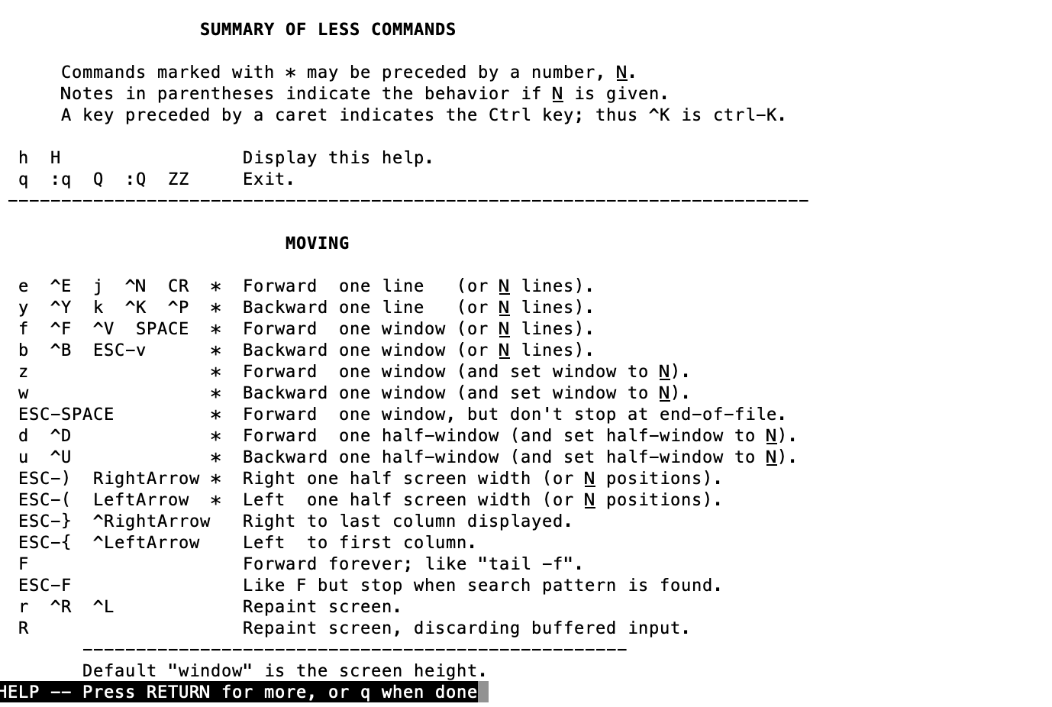

**Step 6: Create a new repository on GitHub**

* Log in to GitHub and create a new repository.
* Obtain the URL of the GitHub repository.



**Step 7: Push Changes to GitHub:**

* Link the local Git repository to the GitHub repository using the following command:

**git remote add origin <GitHub repository URL>**



* Create the token on GitHub to meet the User Authentication.
* Push your changes from the local repository to the remote GitHub repository using the command:

**‘git push origin main’**

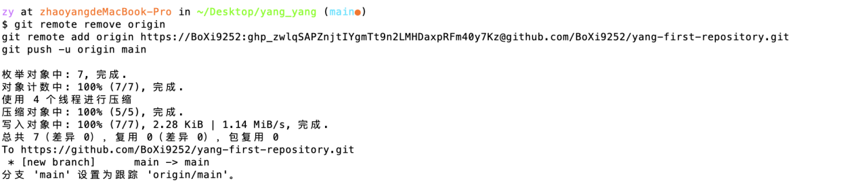

**REVISION HISTORY:**

|  |  |  |  |  |
| --- | --- | --- | --- | --- |
| **Version** | **Date** | **Reviewed By** | **Changed By** | **Summary of Changes** |
| V1.0 | 2024-01-06 | Yang Zhao | Yang Zhao | Initial document completion based on actual operations. |
| V1.1 | 2024-01-10 | Yang Zhao | Yang Zhao | Improved basic structure, added purpose and audience. |
| V1.2 | 2024-01-10 | Lu Liu | Yang Zhao | Revised document structure, grammar, and clarity. |

**ORIGINAL CONTENT LINKS ON GitHub:**

<https://github.com/BoXi9252/yang-first-repository/blob/main/Original_Setting%20Up%20a%20New%20Project%20on%20GitHub.docx>

**Statement Of Changes**

1. Title modified “Setting Up a New Project on GitHub: A Basic Git Workflow”.

**Reason:** Title unclear: The title should be more specific, indicating the content of the document.

1. Analyzed the primary audience of the document, which consists of students intending to use GitHub. Their purpose is likely to understand how to utilize GitHub, so I incorporated consistent language to supplement detailed terminal commands.

**Reason:** To enhance document readability and make the instructions clear and replicable.

1. Adjust the document structure for each crucial process node.

**Reason:** Instructions unclear: There are errors and unclear parts in the instructions, such as the description of steps two and three being mixed together, making it difficult to understand. It is suggested to separate the instructions for each step and provide more specific guidance.

1. Modify fonts and paragraph spacing to maintain clarity within paragraphs and enhance the overall document structure.

**Reason:** To avoid confusion or ambiguity in the document and increase readability.

1. Provide sufficient details and explanations for each step.

**Reason:**Lack of detailed instructions: Some steps in the document lack detailed explanations, which may confuse the readers.